Parent Child Menu (n- Layer)

Help Link : <https://codereview.stackexchange.com/questions/102389/nested-object-to-hierarchical-object-list>

public class Menu

{

public Menu()

{

this.Childrens = new List<Menu>();

}

[Key]

public int Id { get; set; }

public string MenuName { get; set; }

public string Caption { get; set; }

public string MenuType { get; set; }

public string Url { get; set; }

public string ControllerName { get; set; }

public string ActionName { get; set; }

public string Parameter { get; set; }

public int? ParentId { get; set; }

public int OrderIndex { get; set; }

public string Message { get; set; }

public string SettingsGroup { get; set; }

public string Icon { get; set; }

public bool IsActive { get; set; }

public DateTime? CreatedDate { get; set; }

public string CreatedBy { get; set; }

[NotMapped] // attribute used to idicate its not in table

public List<Menu> Childrens { get; set; }

}

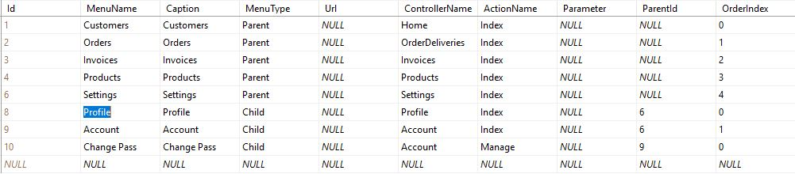

List<Menu> MenuList = new List<Menu>();

MenuList = GetLayers();

#region Parent-Child Recursive Menu

public List<Menu> GetLayers()

{

//call it with parentId=0 initially, to get parentless nodes

return GetChildren(db.Menus.ToList(), null);

}

private List<Menu> GetChildren(IList<Menu> source, int? parentId)

{

var children = source.Where(x => x.ParentId == parentId).ToList();

//GetChildren is called recursively again for every child found

//and this process repeats until no childs are found for given node,

//in which case an empty list is returned

children.ForEach(x => x.Childrens = GetChildren(source, x.Id));

return children;

}

#endregion